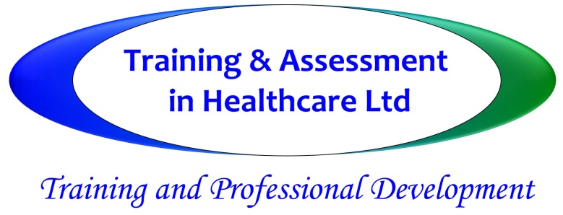

**Leadership Skills**

**The full day course is suitable for all managers, deputies and team leaders, this full day aims to improve knowledge and skills in the day-to-day management and leadership of teams, and for staff to fully understand their accountabilities and responsibilities**

**Course Objectives__________________________________________________________**

* To discuss your role and responsibilities in depth
* To improve leadership, assertiveness and motivational skills – advanced communication skills
* To understand accountability and responsibility
* To review codes of conduct and continued professional and personal development
* To discuss the importance of team building, managing team dynamics and conflict resolution – fostering a positive culture of inclusion and diversity
* To consider record keeping and documentation in relation to all areas of the care provision, revalidation, staff supervision records etc

**Course notes**________________________________________________________

* The session includes group work and discussion.
* We recommend conversations with managers in advance of training delivery to ensure individual or team objectives can be addressed fully and sensitively by the trainer
* This course can be tailored specifically to meet the individual, person-centred needs of your staff – please contact [training@tihcuk.com](mailto:training@tihcuk.com) to arrange a time for further discussion

|  |
| --- |
| **course information** |
| **Duration:** Full day  **Certification:** Certificate of Attendance  **Travel Charge:** Dependent on Location |